2520030045_SAMSHRITHA
WEEK-1 PRACTICAL DATABASE SYSTEM ENGINEERING

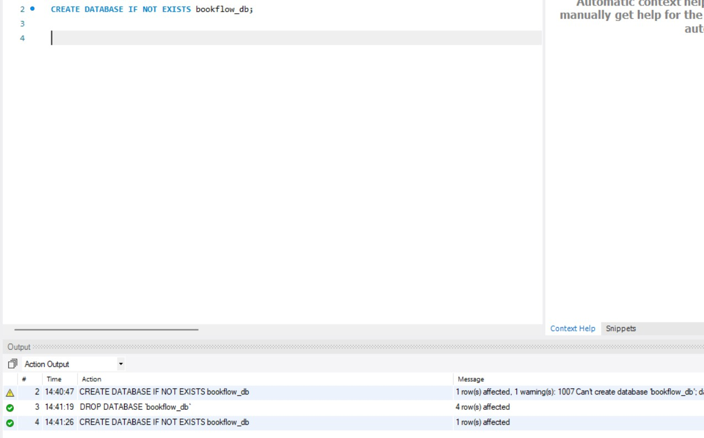
Query : 1 CREATE DATABASE IF NOT EXISTS bookflow_db; output:

Query 2: USE bookflow_db; output:

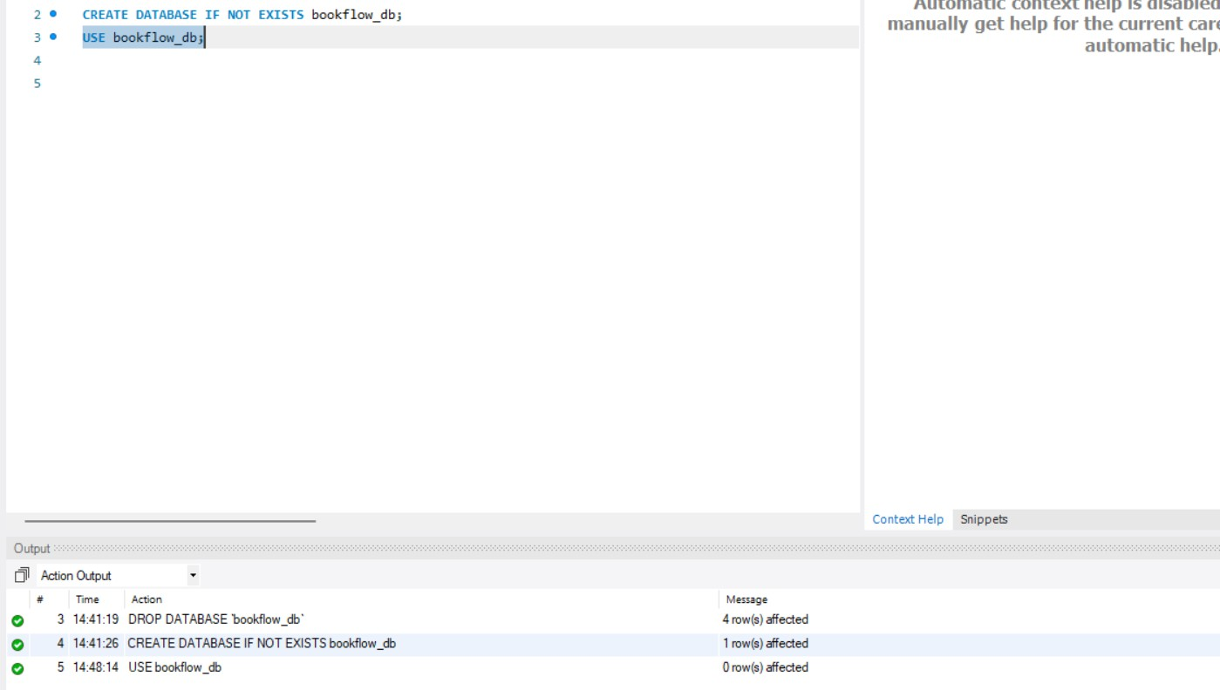
Query 3: CREATE TABLE books ( book_id INT AUTO_INCREMENT PRIMARY KEY, title VARCHAR(255) NOT NULL, isbn VARCHAR(13) NOT NULL UNIQUE,
published_year INT, CONSTRAINT chk_published_year CHECK (published_year < 2027) );
output:

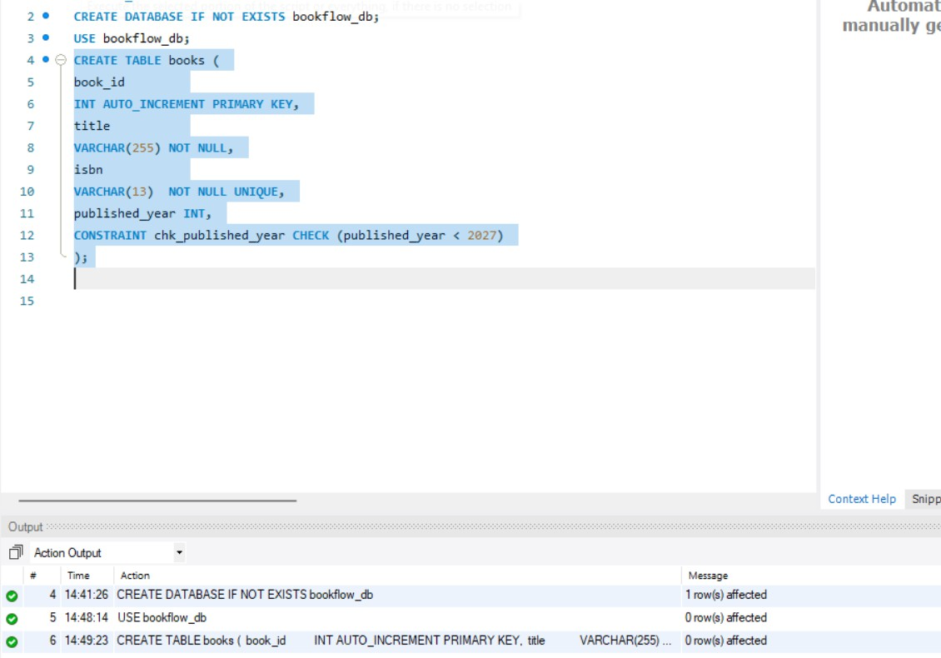
Query 4: Create the members table CREATE TABLE members ( member_id INT AUTO_INCREMENT PRIMARY KEY, full_name VARCHAR(100) NOT NULL, email VARCHAR(150) NOT NULL UNIQUE );
output:

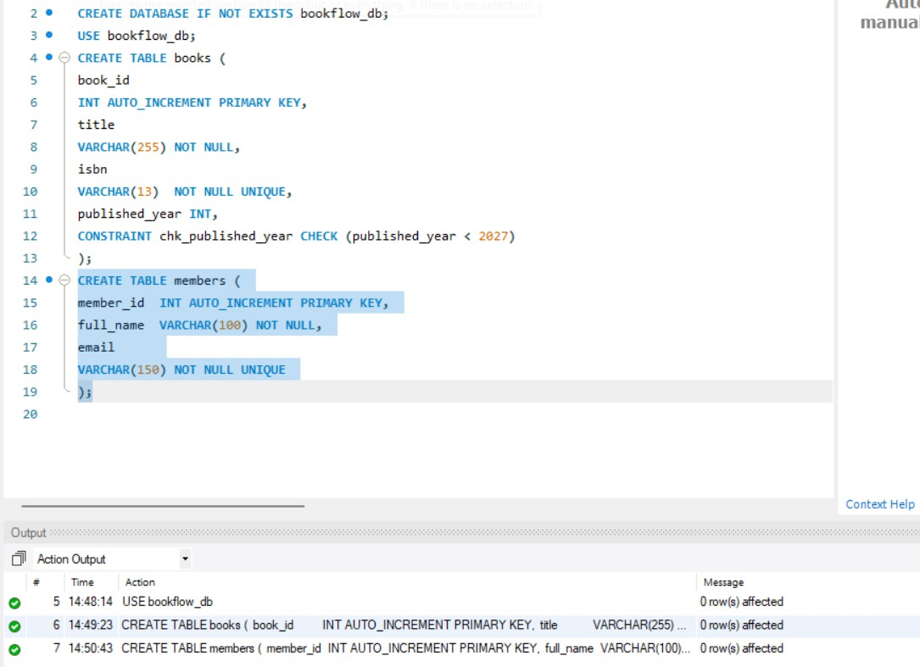
Query 5 (verification): Inspect the table structures DESCRIBE members; output:

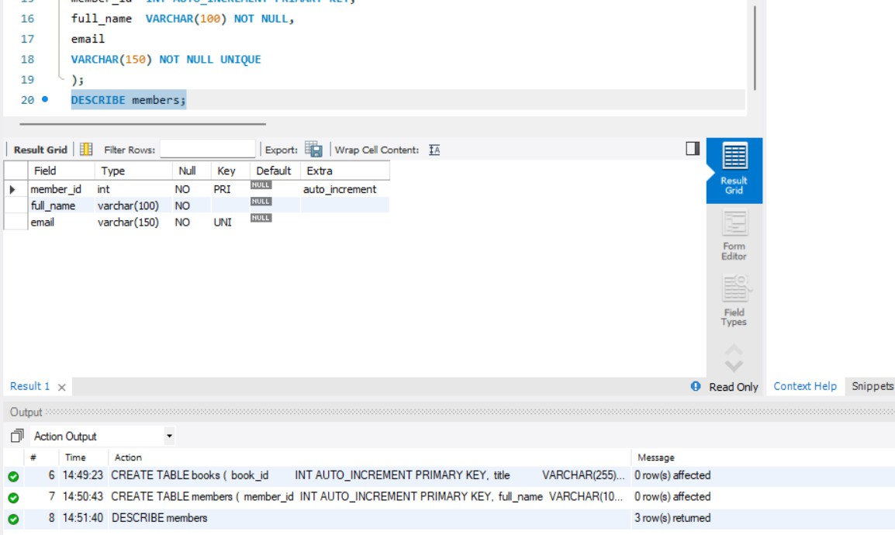
Query 6: Insert 3 books INSERT INTO books (title, isbn, published_year) VALUES ('The Alchemist', '9780061122415', 1988), ('Clean Code', '9780132350884', 2008), ('Atomic Habits', '9780735211292', 2018);
output:

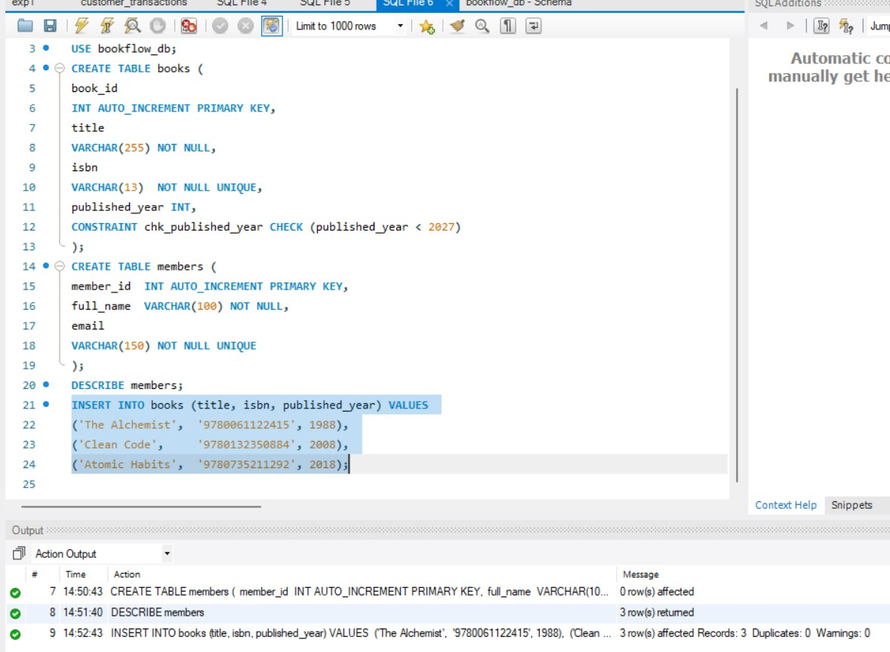
Query 7: Insert 3 members INSERT INTO members (full_name, email) VALUES ('Anil Kumar', 'anil.kumar@example.com'), ('Priya Sharma', 'priya.sharma@example.com'), ('Ravi Verma', 'ravi.verma@example.com');
output:

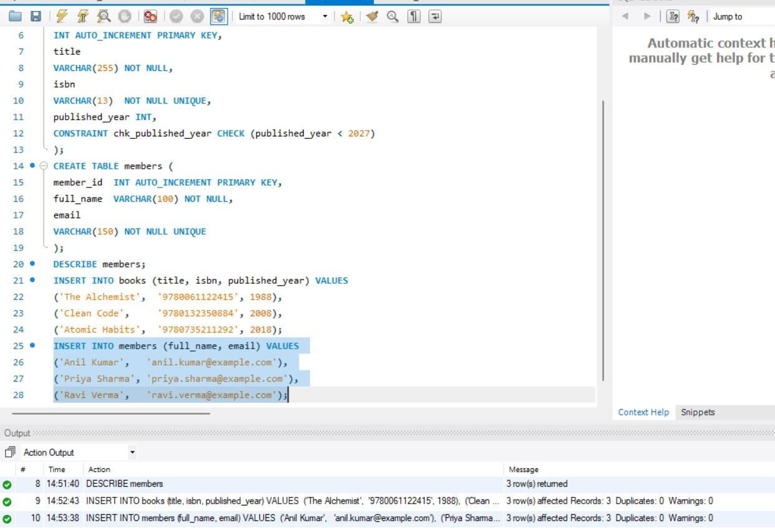

Test 1: Duplicate ISBN (UNIQUE violation) INSERT INTO books (title, isbn, published_year) VALUES ('Fake Copy', '9780061122415', 2000);
output:
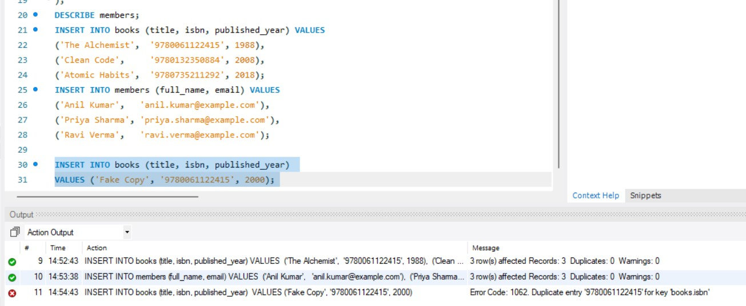
Test 2: NULL title (NOT NULL violation) INSERT INTO books (title, isbn, published_year) VALUES (NULL, '9999999999999', 2010);
output:

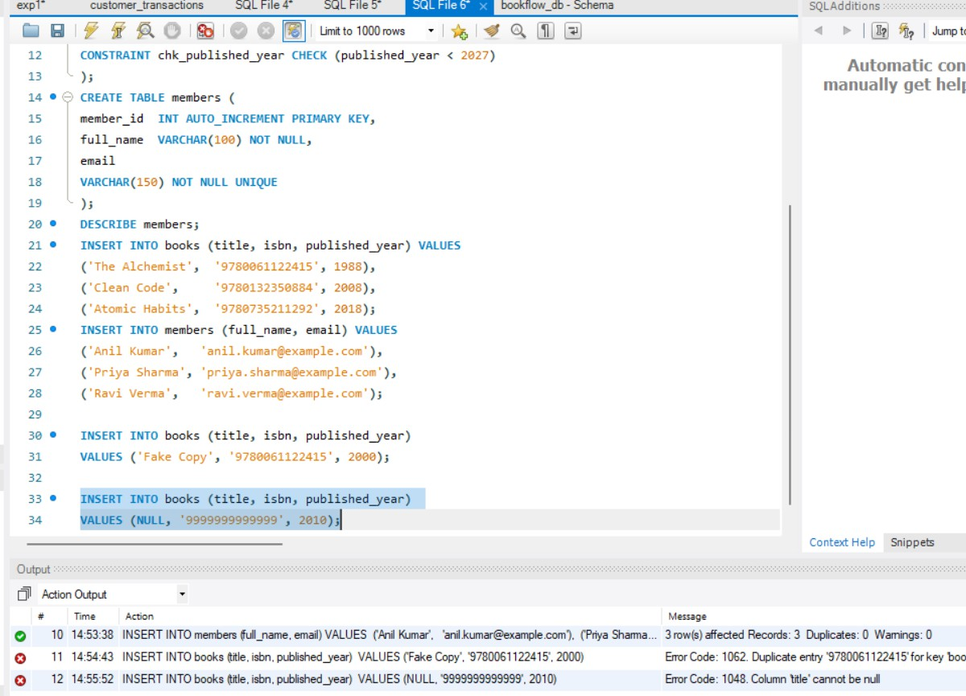
Test 3: Future publication year (CHECK violation) INSERT INTO books (title, isbn, published_year) VALUES ('Time Traveler', '8888888888888', 2030);
output:

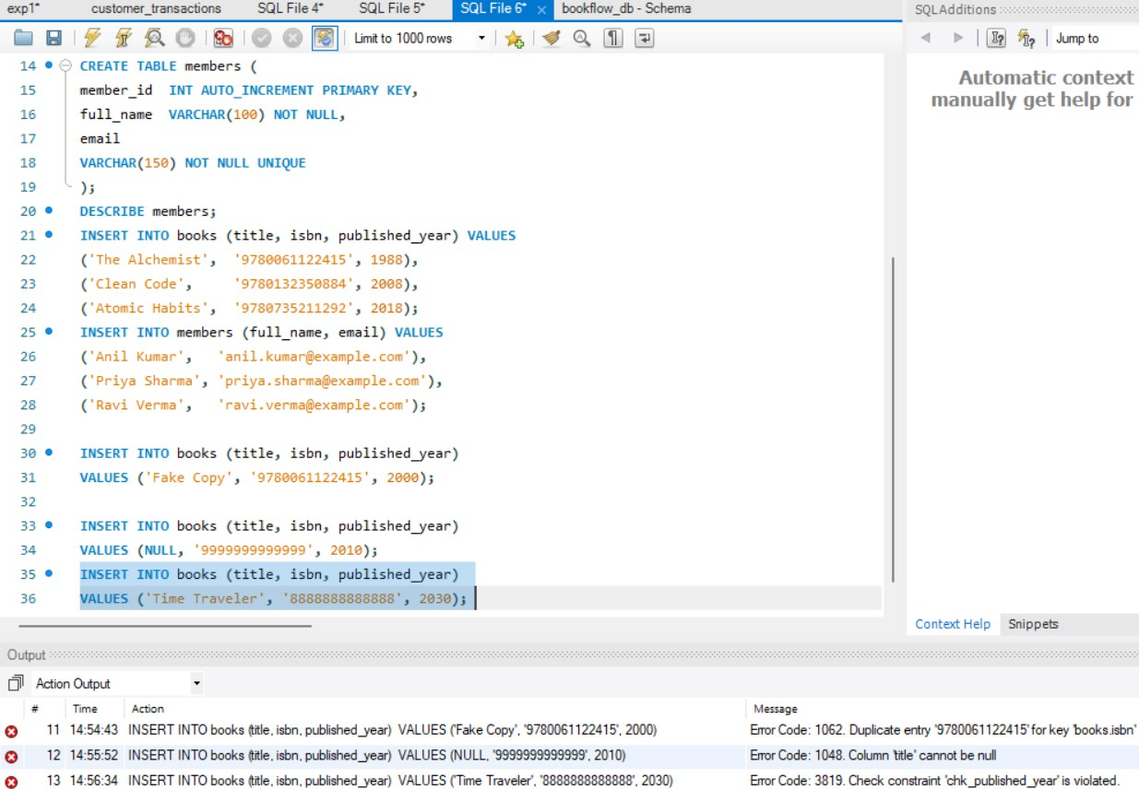

Test 4: Duplicate email (UNIQUE violation) INSERT INTO members (full_name, email) VALUES ('Anil Clone', 'anil.kumar@example.com');
output:

